Module 4: Critical Thinking

Bryan Moffett
Colorado State University Global
ITS410: Database Management
Dr. Raquel Hicks
September 13th, 2026

Modifying Tables in My Guitar Shop Database
Task 1.3 - Insert a New Category
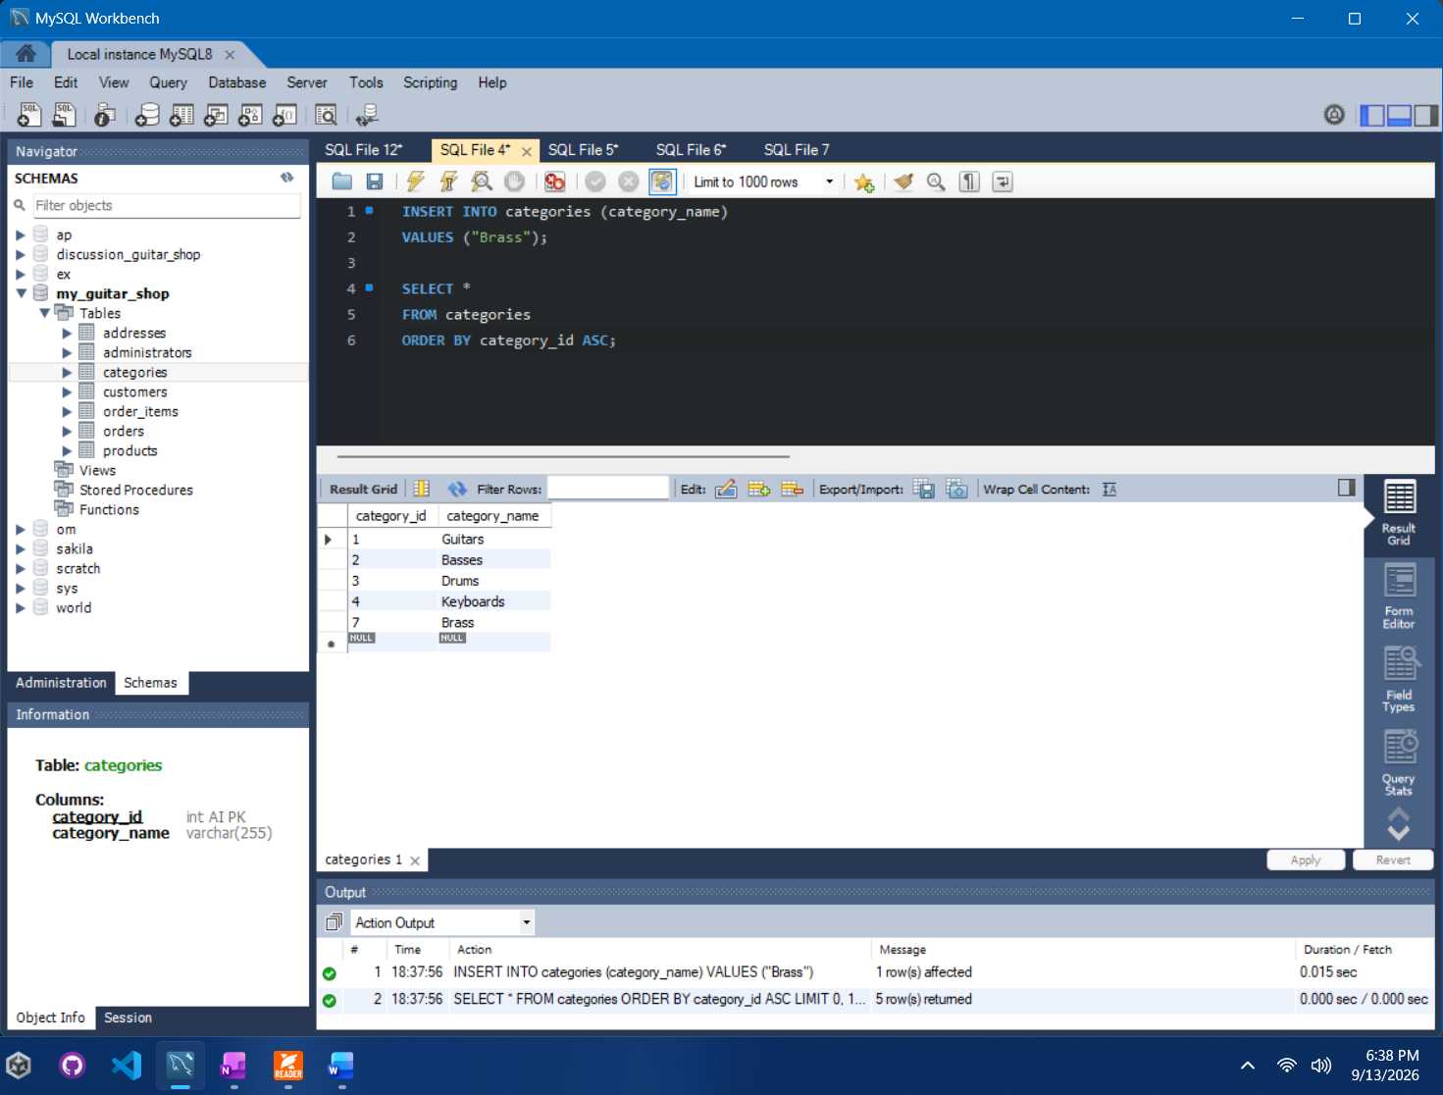

Task 2.3 - Update the New Category Name
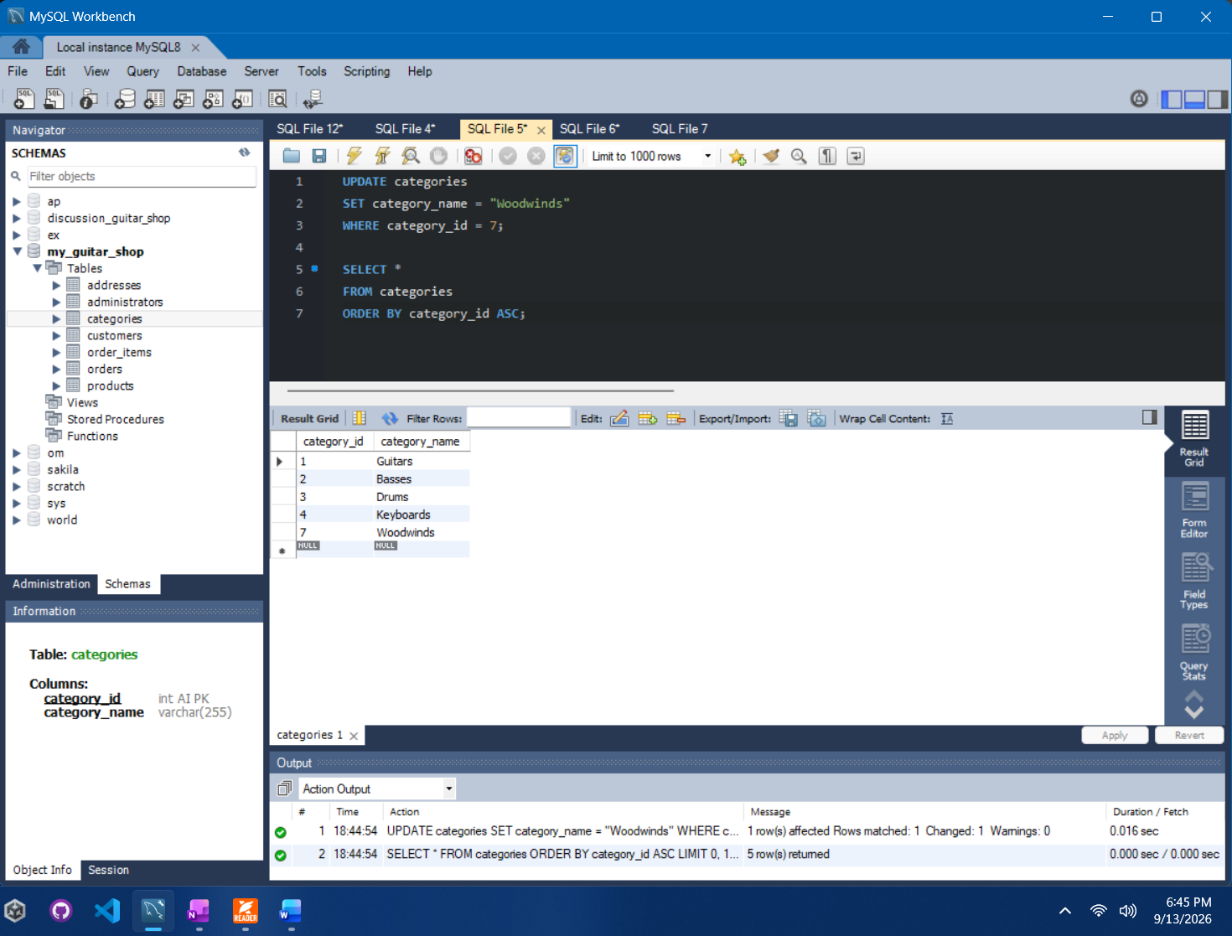

Task 3.3 - Delete the Category Row
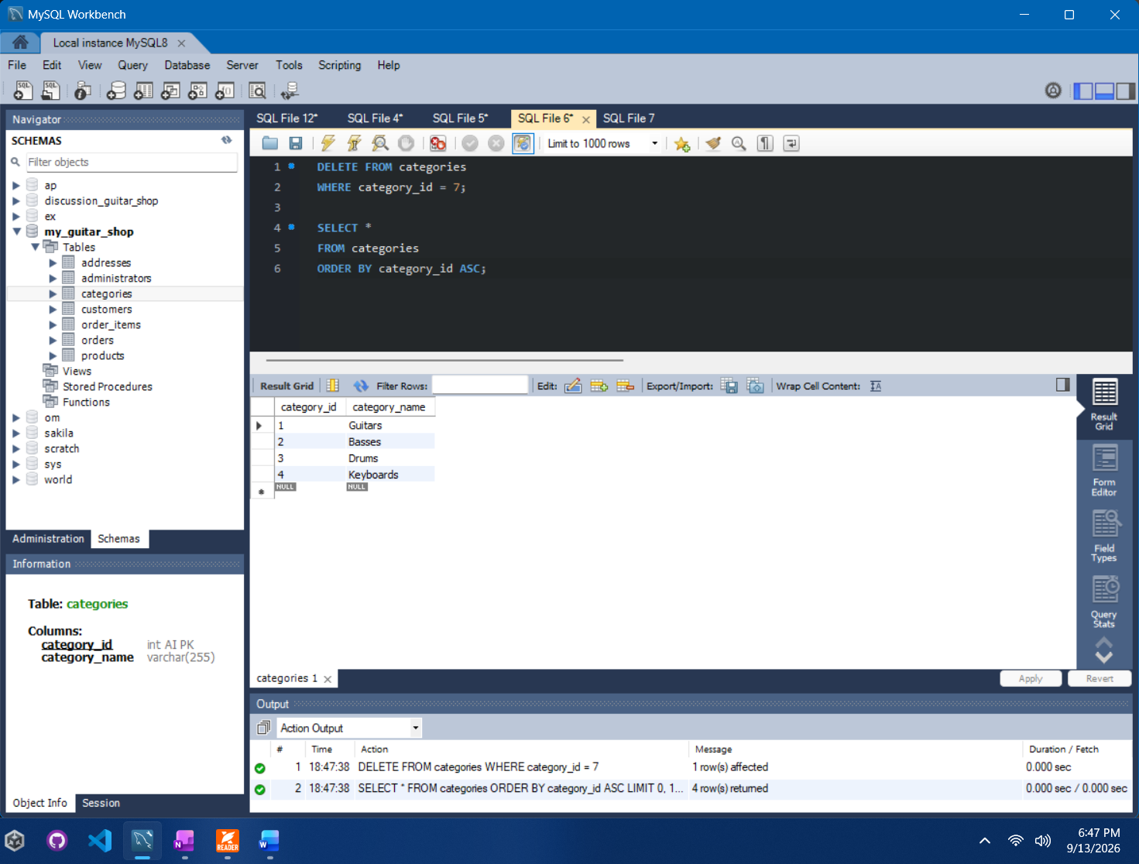

Task 4.3 - Insert a New Product
